General Science Study Guide Name______________________________
1) Fill in the blanks for each of the following.
a. Someone studying the expansion of the universe is studying ______________________.
b. Someone studying the occluded front that’s causing hail is studying ______________________.
c. Someone studying the depletion of coral reefs is studying ______________________.
d. Someone studying the acidity of soil samples is studying ______________________.

2) For each of the following scenarios, list the two letters that most represent the systems interacting.
a. lithosphere b. biosphere c. atmosphere d. hydrosphere
_____ a. bird is flying _____ b. tornado appears dusty _____ c. hail falls from the air
_____ d. mud is formed _____ e. beaver sits on a rock _____ f. tree branches sway back and forth

3) Place the following words/terms in one of the five categories listed below: matter, matter and space, Newton, g/cm3, L*W*H, distance, g, m, L, meter stick, scale, graduated cylinder, gravity.
Mass Length Volume Density Weight

4) What unit of measurement is the only one to have a standard unit different from its base unit? What is this form of measurement’s standard unit and why?

5) For each of the following, write down the appropriate unit you would use to measure in each scenario.
_____a. taking the mass of a person
_____b. measuring the length of the white of a person’s fingernail
_____c. determining the volume of water in a pool
_____d. measuring the width of a lab cabinet
_____e. measuring the volume in a small fish tank

6) Solution A has a mass of 2.5 g and volume 1.25 cm³. Solution B has a mass of 6.0 g and a volume of 1.50 cm³. Which solution will float on top of the other?

7) For each of the following, write LAT for latitude and LONG for longitude.
_____a. prime meridian _____ b. max 90 degrees _____c. runs north to south
_____d. measured east or west _____e. equator _____f. runs east to west
_____ g. measured north or south _____h. max 180 degrees _____i. run parallel
_____ j. intersect

8) List the steps of the scientific method in order.

9) A _________________ is the predicted outcome of your experiment. The _________________ should directly accept or reject your predicted outcome.

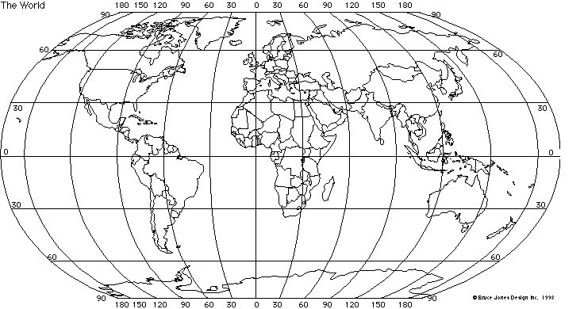
10) Plot the following points. Label each one with the appropriate letter.
A. 60˚S, 30 ˚E B. 90˚N, 0˚ C. 30˚N, 150 ˚W D. 0˚, 90 ˚E

11) You are conducting an experiment to determine if increased ultraviolet radiation from the decrease in the ozone layer is killing off frog tadpoles. After examining all of the data available in the library, you decide to go with a hypothesis that increased ultraviolet radiation from the sun is killing off the tadpoles.
You design an experiment with a control and an experimental group. Group 1 involves 100 tadpoles in a five gallon container of water, which is covered by glass (knowing that the glass will filter out the ultraviolet radiation). Group 2 will be set up exactly like group 1, except that instead of being covered with glass, it is covered with an acrylic plexiglass, which will not filter out the U.V. radiation. You then place the groups outside for a period of a month, and observe the results. The same container and same water source was used for each group.
Results
Group 1 Group 2
Number of tadpoles 100 100
started with
Number finished 96 96
a. The container being the same and having the same water source for each group are examples of ____________.
b. What group is the control in this experiment?
c. What is the dependent variable?
d. What is the independent variable?
e. Was the hypothesis correct?
12) List 3 sustainable practices. Remember, sustainability incorporates social, economic, and environmental concerns.

